AI Assignment-13

Jeetu Mehra
U24AI032

Question 1 : 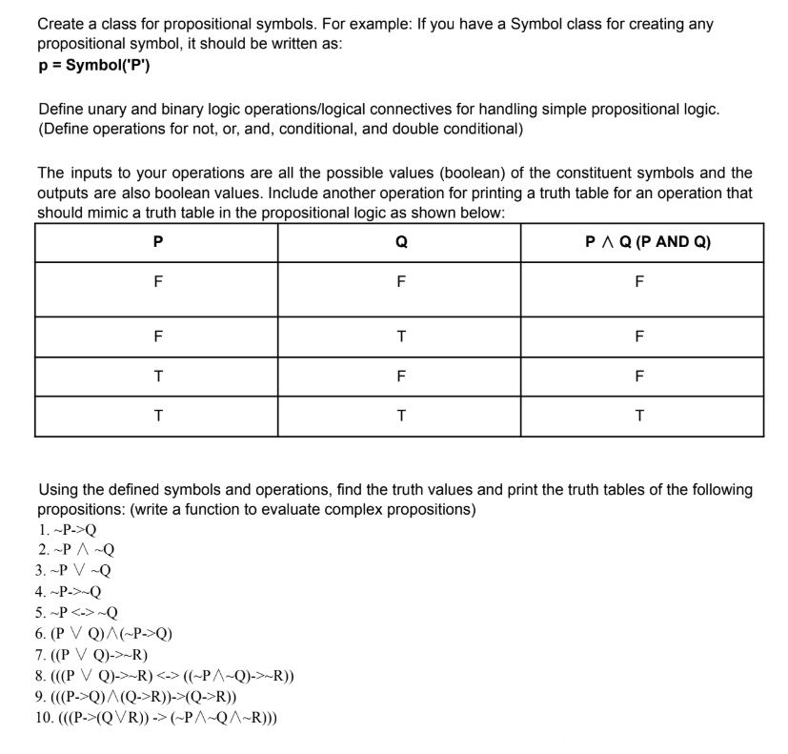
Code:
import itertools

# ---------------- SYMBOL CLASS ----------------
class Symbol:
def __init__(self, name):
self.name = name

def evaluate(self, values):
return values[self.name]

def __repr__(self):
return self.name

# ---------------- UNARY OPERATOR ----------------
class Not:
def __init__(self, operand):
self.operand = operand

def evaluate(self, values):
return not self.operand.evaluate(values)

def __repr__(self):
return f"¬({self.operand})"

# ---------------- BINARY OPERATORS ----------------
class And:
def __init__(self, left, right):
self.left = left
self.right = right

def evaluate(self, values):
return self.left.evaluate(values) and self.right.evaluate(values)

def __repr__(self):
return f"({self.left} ∧ {self.right})"

class Or:
def __init__(self, left, right):
self.left = left
self.right = right

def evaluate(self, values):
return self.left.evaluate(values) or self.right.evaluate(values)

def __repr__(self):
return f"({self.left} ∨ {self.right})"

class Implies: # P → Q
def __init__(self, left, right):
self.left = left
self.right = right

def evaluate(self, values):
return (not self.left.evaluate(values)) or self.right.evaluate(values)

def __repr__(self):
return f"({self.left} → {self.right})"

class Iff: # P ↔ Q
def __init__(self, left, right):
self.left = left
self.right = right

def evaluate(self, values):
return self.left.evaluate(values) == self.right.evaluate(values)

def __repr__(self):
return f"({self.left} ↔ {self.right})"

# ---------------- TRUTH TABLE FUNCTION ----------------
def truth_table(expr, symbols):
print(f"\nTruth Table for: {expr}")
print(" | ".join([s.name for s in symbols]) + " | Result")
print("-" * (len(symbols) * 4 + 10))

for values_tuple in itertools.product([False, True], repeat=len(symbols)):
values = dict(zip([s.name for s in symbols], values_tuple))
result = expr.evaluate(values)

row = " | ".join(['T' if values[s.name] else 'F' for s in symbols])
print(f"{row} | {'T' if result else 'F'}")

# ---------------- MAIN PROGRAM ----------------
if __name__ == "__main__":
P = Symbol('P')
Q = Symbol('Q')
R = Symbol('R')

# 1. ¬P → Q
expr1 = Implies(Not(P), Q)

# 2. ¬P ∧ ¬Q
expr2 = And(Not(P), Not(Q))

# 3. ¬P ∨ ¬Q
expr3 = Or(Not(P), Not(Q))

# 4. ¬P → Q (same as 1)
expr4 = Implies(Not(P), Q)

# 5. ¬P ↔ ¬Q
expr5 = Iff(Not(P), Not(Q))

# 6. (P ∨ Q) ∧ (¬P → Q)
expr6 = And(Or(P, Q), Implies(Not(P), Q))

# 7. (P ∨ Q) → R
expr7 = Implies(Or(P, Q), R)

# 8. ((P ∨ Q) → R) ↔ ((¬P ∧ Q) → R)
expr8 = Iff(
Implies(Or(P, Q), R),
Implies(And(Not(P), Q), R)
)

# 9. ((P → Q) ∧ (Q → R)) → (P → R)
expr9 = Implies(
And(Implies(P, Q), Implies(Q, R)),
Implies(P, R)
)

# 10. ((P → (Q ∨ R)) → (¬P ∧ ¬Q ∧ ¬R))
expr10 = Implies(
Implies(P, Or(Q, R)),
And(Not(P), And(Not(Q), Not(R)))
)

# PRINT ALL TRUTH TABLES
truth_table(expr1, [P, Q])
truth_table(expr2, [P, Q])
truth_table(expr3, [P, Q])
truth_table(expr4, [P, Q])
truth_table(expr5, [P, Q])
truth_table(expr6, [P, Q])
truth_table(expr7, [P, Q, R])
truth_table(expr8, [P, Q, R])
truth_table(expr9, [P, Q, R])
truth_table(expr10, [P, Q, R])

